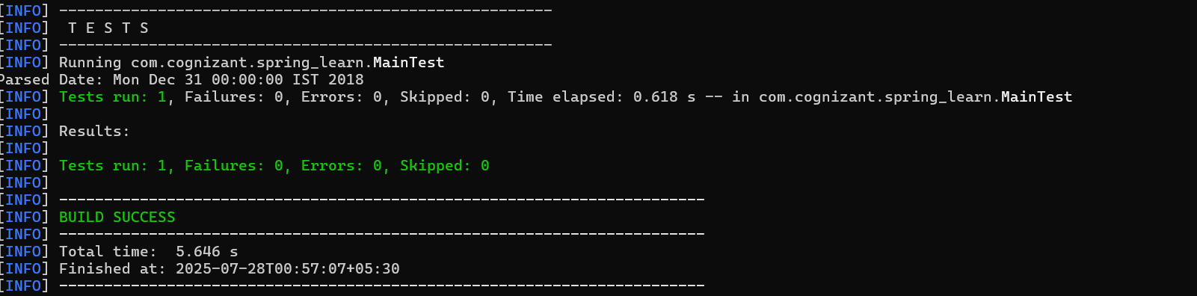
Hands on 2-
Spring Core – Load SimpleDateFormat from Spring Configuration XML :
Main.java:

package com.cognizant.spring_learn;

import org.springframework.context.ApplicationContext;
import org.springframework.context.support.ClassPathXmlApplicationContext;

import java.text.ParseException;
import java.text.SimpleDateFormat;
import java.util.Date;

public class Main {

public static void main(String[] args) throws ParseException {
displayDate();
}

public static Date displayDate() throws ParseException {
ApplicationContext context = new ClassPathXmlApplicationContext("date-format.xml");
SimpleDateFormat format = context.getBean("dateFormat", SimpleDateFormat.class);
Date date = format.parse("31/12/2018");
System.out.println("Parsed Date: " + date);
return date;
}
}

MainTest.java:
package com.cognizant.spring_learn;

import org.junit.Test;

import java.text.ParseException;
import java.text.SimpleDateFormat;
import java.util.Date;

import static org.junit.Assert.assertEquals;

public class MainTest {

@Test
public void testDisplayDate() throws ParseException {
Date expected = new SimpleDateFormat("dd/MM/yyyy").parse("31/12/2018");
Date actual = Main.displayDate();
assertEquals(expected, actual);
}
}

Date-Format.xml:

<?xml version="1.0" encoding="UTF-8"?>
<beans xmlns="http://www.springframework.org/schema/beans"
xmlns:xsi="http://www.w3.org/2001/XMLSchema-instance"
xsi:schemaLocation="http://www.springframework.org/schema/beans
https://www.springframework.org/schema/beans/spring-beans.xsd">
<bean id="dateFormat" class="java.text.SimpleDateFormat">
<constructor-arg value="dd/MM/yyyy" />
</bean>
</beans>

Output:

